2021 Sponsor and Exhibitor Kit
Welcome to our community of assessment practitioners! AALHE works hard to create a welcoming, inclusive, and active community of volunteers, members, newcomers and assessment rock stars.

If you have any questions about the following information detailing our sponsorship opportunities, please reach out to Lorna Keach at lkeach@aalhe.org.

Conference Day/Time
AALHE 2021 Online will take place Monday, June 7th – June 11th, 10am to 5pm Central time, online via the conference platform, Whova with integrated Zoom live meetings as well as On Demand presentations.

Registration
All attending Exhibitors and should purchase their sponsorship packages no later than May 28, 2021.

Those exhibitors receiving free registration(s) as a part of their sponsorship package receive a promo code to waive their registration fee. The package purchase form may be found here: https://www.aalhe.org/aalhe-2021-sponsor-registration

Past sponsors and exhibitors will also receive an Encore discount of 20% off the final package purchase. Please email Lorna Keach at lkeach@aalhe.org if you have not received your Encore discount code.

Login and Materials Due Dates
Registered sponsors may log in to the conference platform here: https://whova.com/portal/webapp/aalhe_202102/

Exhibitor and Exemplar sponsor logins will first be sent May 17, 2021.

Sponsors must update profiles and upload their materials including videos, handouts, invited session information (title, abstract, and Zoom link) before May 28, 2021.

Access to the conference platform will be given to attendees June 1. Live events will begin the following Monday, June 7.

Sponsorship Package Details
Exhibitor Package - $500
- 1 registration grant for an attendee (a $135 value). Exhibitor will be included on the Friends of AALHE page.
  - Sponsors organizational logo, contact names and email, and their grant sponsorship will be listed on this page: https://www.aalhe.org/meet-our-2021-sponsors
  - Registration grant recipients will be notified of their award in April and May, 2021.
  - An email with your organization’s grant recipient’s name and email address will be sent to exhibitors and sponsors by June 1, 2021.
- Inclusion of Exhibitor logo and link to sponsor homepage on the aalhe.org website
  - Logos will appear in Meet our Sponsors page as well as rotating on the right-hand widget labeled “conference sponsors” on the home page and every subsequent page of the website.
- 1 full conference non-member registration (a $350 value)
  - This registration is included with the Exhibitor package at the non-member rate. See full fee schedule here. One individual from your organization may attend any event at AALHE 2021 and have full access to the conference website. This includes the ability to message attendees via the platform, interact during networking events, and participate as an attendee in skills development and other presentations.
- Inclusion of Exhibitor logo and thanks on the AALHE 2021 Online program, slideshows, emails, and other materials distributed to attendees.
  - Exhibitors are asked to include an upload of their logo on the sponsor registration form. If no logo is included on the form, a logo will be requested by email and updated on the conference materials within 1 week.

Exemplar Package - $1500
The Exemplar package includes ALL the benefits included in the Exhibitor package as well as the following:
- 2 additional registration grants for attendees (a $270 value) and top-tier inclusion of the Friends of AALHE page.
  - Sponsors organizational logo, contact names and email, and their grant sponsorship will be listed on this page: https://www.aalhe.org/meet-our-2021-sponsors
  - Registration grant recipients will be notified of their award in April and May, 2021.
  - An email with your organization’s grant recipient’s name and email address will be sent to exhibitors and sponsors by June 1, 2021.
  - 2 additional conference registrations for sponsor team (a $700 value).
  - These registrations are included with the Exemplar package at the non-member rate. See full fee schedule here. A total of 3 individuals from your organization may attend any event at AALHE 2021 Online and have access to the full conference website. This includes the ability to message attendees via the Whova attendee hub, interact during networking events, and participate as an attendee in skills development and other presentations.
- 1 "Invited Session" during the week of June 7-11 and optional inclusion of the live session's recording in the On-Demand offerings.
  - Sponsor’s invited session will be included in the conference program schedule via the Whova attendee hub with the concurrent sessions, outside the exhibitor or sponsor areas.
  - In order to provide the best experience possible for sponsors and attendees, sponsors will arrange the meeting to take place via their own Zoom license/meeting room and be moderated by sponsor staff.
  - Any staff required for the invited session presentation may attend this sponsored session/Zoom meeting. However, for full access to all the conference offerings, registration is required.
- Full opt-in attendee registration list including name, email, title, and organization of individuals.
  - Due to the likelihood of last-minute registrations, the attendee list will be emailed no sooner than Monday, June 1, 2021, and no later than Monday, June 7th, 2021.

A La Carte Offerings
- $150 - 1 registration grant for an attendee ($135 value). Your branding will be included on the Friends of AALHE page.
  - This offers the exhibitor or exemplar sponsor the ability to purchase additional attendee registration grants.
  - Sponsors organizational logo, contact names and email, and their grant sponsorship will be listed on this page: https://www.aalhe.org/meet-our-2021-sponsors
  - Registration grant recipients will be notified of their award in April and May, 2021.
  - An email with your organization’s grant recipient’s name and email address will be sent to exhibitors and sponsors by June 1, 2021.
- $200 - Social media rock stars receive 3 shout-out posts via Instagram, Twitter, and LinkedIn (three available).
  - 1 shout-out per platform is available for a grand total of 3.
  - Sponsors must choose 3 dates for the shout-outs offered by AALHE Communications Committee.
  - Logo, link, and content suggestions may be provided by the sponsor; ultimate construction of shout-out will be determined by the Communications Committee.
  - Example shout out 1: AALHE thanks sponsor [name.] [Sponsor] offers programs geared toward working adults. Scholarships are available. For more visit [link]
- $500 - Sponsor one of AALHE's popular Speed Networking events! Your branding will be included on the program as the event sponsor, with the opportunity to select the conversation starter questions (two available).
  - Speed networking events are live meetings that include conversation starter questions and the opportunity for the attendees to talk freely in Zoom.
  - Breakout rooms are randomly assigned to attendees, in which they are given 5-10 minutes to talk. After which point, the breakout rooms are reassigned to allow attendees to speak to new parties.
  - Sponsor will be thanked by name in the opening discussion and may choose to select conversation starter questions and invite staff to the Zoom meeting. These staff will have access to the Speed Networking event only; for access to all other events, conference registration is required.
- $1000 - Sponsor the AALHE 2021 Online Volunteer Thank-you gift (one available)
  - To be determined. If you are interested in this sponsorship opportunity, please reach out to Lorna Keach (lkeach@aalhe.org) or Angela Hoffman-Cooper at (ahcooper@aalhe.org).

Custom packages
Custom packages are available. If you are interested in discussing a custom package, please contact Angela Hoffman-Cooper for more information ahcooper@aalhe.org

Conference platform Exhibitor and Sponsor areas
The conference platform for AALHE 2021 Online, Whova, includes areas in which Exhibitors and Exemplar Sponsors may connect with attendees. Whova has included helpful tutorials on navigating the platform as well as lead generation within the event: https://whova.com/resources/how-to-guide/leadgen-tutorial/

Exhibitor area
For AALHE 2021 Online, the Exhibitor area includes entries for each organization purchasing an Exhibitor package.
- Contact information, logo, description, page views, and contact information.
- PDFs for 10 MB or smaller may be attached to this entry.
- Recommended size for exhibitor logos are 256px by 256px (max 1000px by 1000px).
- Videos and live showcases are not included in the Exhibitor areas for AALHE 2021.
- “Deals and Offers” button creates a dialogue button that allows attendees to reach out to Exhibitor directly.
- Those purchasing A La Carte offerings with no additional package will be featured in the Exhibitor area of the conference platform only.
- See the Whova Exhibitor guide here: https://whova.com/pages/whova-app-exhibitor-guide/
- All Exhibitors, Exemplar Sponsors, and Custom packages will receive an Exhibitor area entry.

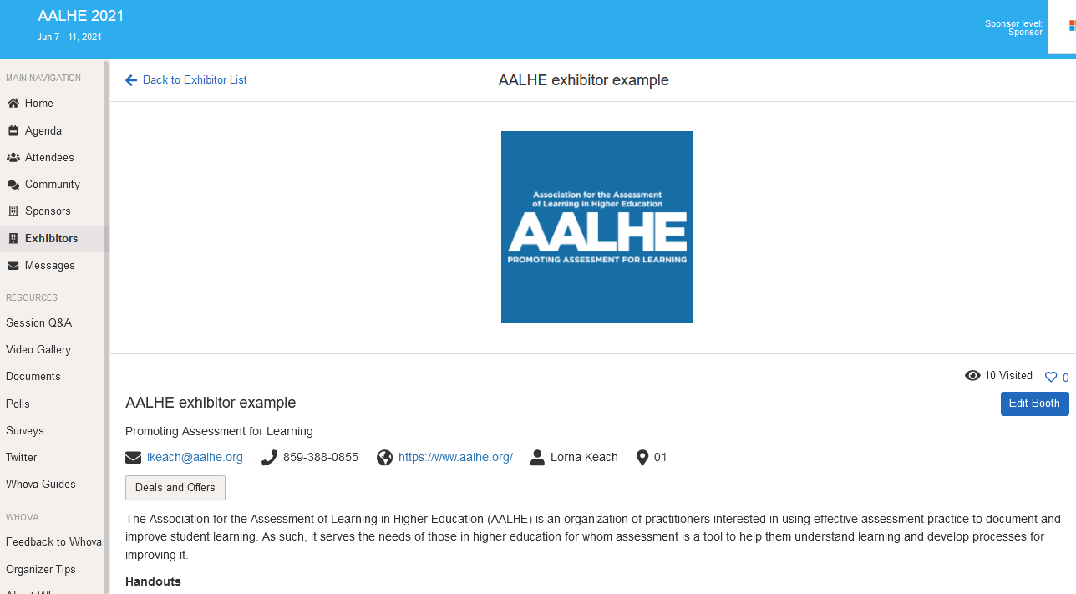
Example of Exhibitor area entry with contact information.

Exemplar Sponsor area
This additional area allows Exemplar sponsors and those with Exemplar+ custom packages to include additional videos and engagement materials for attendees.
- Logos will be displayed on the sponsor video page as well as the top page banner.
- Recommended image dimensions for video page is 700px x700px (max 1000px by 1000px).
- At this time, live showcases will not be included in the conference program. Should a sponsor wish to host a live game, networking, or other social session, they are welcome to do so using this feature, provided that the sponsor’s Zoom meeting room is utilized. Sponsors are welcome to reach out to conference admin should they wish to include the days/times of live showcases in the daily events emails to members.
- All Exhibitors, Exemplar Sponsors, and Custom packages will receive an Exhibitor area entry, but only Exemplar Sponsors will receive a Sponsor Area entry.

Example of Sponsor area Video with contact information.

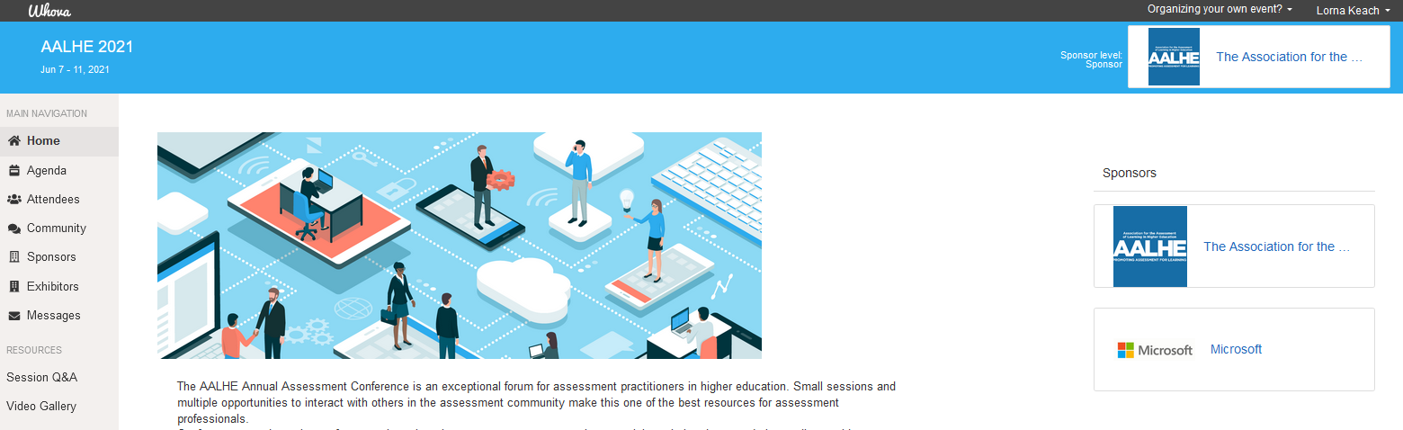
Example sponsor logo in header and sidebar.
Exhibitor vs Sponsor areas
The Sponsor Center will include Exemplar sponsors only. According to Whova, “The Sponsor Center's main goal is to increase the sponsor company's brand awareness. Sponsor banners are shown throughout the Whova mobile and web apps.”

The Exhibitor Center will include BOTH Exemplar sponsors and Exhibitors. According to Whova, “The Exhibitor Center's main goal is to help participants generate leads. It allows exhibitors to collect leads info when attendees sign up for the exhibitor's offering or when an exhibitor scans an attendee's QR code. You can also enable Passport Contest from the Exhibitor Center to generate more traffic to the exhibitor booths.”

Indemnification

Exhibitor shall indemnify, hold harmless and defend AALHE, its governors, trustees, officers, faculty, students, agents, and employees against any and all damages, suits, actions, claims, liabilities, losses, judgments, costs and expenses arising out of or relating to (i) any personal or bodily injury (including death) or property damage caused by exhibitor’s negligent, willful, or unlawful acts or omissions or breach of this Agreement, (ii) breach of exhibitor’s confidentiality obligations, or (iii) any third party claims relating to the event, advertising, product liability claims, or infringement of any trademark, copyright, patent, trade secrets or nonproprietary right of a third party (including, without limitation, defamation, libel or violation of privacy or publicity) excluding damages, suits, actions, claims, liabilities, losses, judgments, costs and expenses arising out of or relating to AALHE’s own negligent acts or omissions, willful misconduct, breach, or infringement.

Conference Sponsor Agreement
This agreement is entered into by and between the Association for the Assessment of Learning in Higher Education (AALHE), a non-profit entity, 60 Terra Cotta Ave. Suite B #307, Crystal Lake, IL and _________________________ (Exhibitor).
AALHE and Exhibitor herby agree:

- As consideration for the level and opportunities selected above of the above, Exhibitor agrees to pay AALHE the total sum of $ _____ no later than May 28, 2021. Agreement must be signed within 5 days of receipt in order to assure that the level requested can be held for exhibitor.

- Exhibitor may cancel this agreement without penalty upon written notice delivered to AALHE prior to March 15, 2021. If Exhibitor cancels this agreement after March 15, 2021 but before April 15, 2021, Exhibitor agrees to pay 50% of the total sum as a cancellation fee. No refund will be given if Exhibitor cancels after April 15, 2021.
- If for any reason either party cannot make the agreed upon opportunities available on the specified date(s) because of fire, accident, strike, civil unrest, acts of God, or other causes beyond either parties’ control, AALHE’s sole and complete responsibility to Exhibitor will be the refund of any sums paid by Exhibitor under this agreement related to the said date(s).
In witness whereof, the undersigned competent representatives do hereby enter into this agreement for use of facilities as the day and year first written above.

AALHE PRINT NAME/TITLE: Angela Hoffman-Cooper, Executive Director
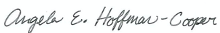
SIGNATURE:
_____________________________________________________________ Date: 03/25/2021

SPONSOR GROUP: _________________________________________________________________________________

PRINT NAME/TITLE: _________________________________________________________________
ADDRESS: ________________________________________________________________________________

SIGNATURE: _________________________________________________ Date: _____________

Conference Admin Contacts
If you have questions or require assistance at any time, the conference admin contacts are below.
  - Lorna Keach – Administrative Assistant – lkeach@aalhe.org
  - Angela Hoffman-Cooper – Executive Director – ahcooper@aalhe.org
  - Josie Welsh – President Elect – jwelsh@aalhe.org

Thank you!
Your involvement with AALHE 2021 Online not only adds value to our attendees’ experience, but it also helps bolster a community of assessment practitioners and professionals doing excellent work in their institutions and communities.

